

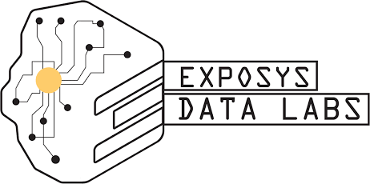

**A**

**Project Report On**

**“Video Chatting Website”**

**Duration: *12/02/2022 - 20/03/2022***

**SUBMITTED BY: SUBMITTED TO:**

**SIDDHI MISHRA EXPOSYS Data Labs**

(Electronics Engineering) Bengaluru, Karnataka. Institute of Engineering and

Rural TECHNOLOGY,PRAYAGRAG, Uttar Pradesh.

# ACKNOWLEDGEMENT

Internship is an integral part of engineering curriculum providing engineers with first hand and practical aspects of their studies. It gives them the knowledge about the work and circumstances existing in the company. The preparation of this report would not have been possible without the valuable contribution of the Exposys Data Labs family comprising of several experienced engineers in their respective field of work. It gives me great pleasure in completing my internship at Exposys Data Labs and submitting the internship project report for the same.

Our sincere thanks to **Mr. Aravind, R&D Engineer** for continuously guiding throughout various aspect and supported us constantly and channelize our work toward more positive manner

A major contribution of this work would definitely be my parents who have constantly supported me for my internship in here and my friends who have always been there as a pillar of strength.

# PREFACE

In any organization success or failure of the company depend upon 4 M's i.e. Materials, Men, Machine and Method. Today is the age of competition and an organization cannot survive without satisfaction of its customers. Quality of material is to be maintained in order to stand in the competitive market.

To be a perfect engineer one must be familiar with individual experience in industrial environment. He must be aware of basic industrial problems and their remedies.

While undergoing this internship EXPOSYS Data Labs, Bengaluru, Karnataka. I learned a lot of practical aspect. My theoretical knowledge was exposed here practically. In this report I had give details of my project assign to me from EXPOSYS Data Labs.

# Table of contents:-

* Overview & Basic Knowledge of Exposys Data Labs.
* Overview about Web Developer Intern.
* Project Details.
* Declaration.
* Detailed Work on Project.
* Project Specification.

# Overview & Basic Knowledge of Exposys Data Labs.

EXPOSYS Data Labs is a world leader in Robotics, Universe Intelligence (UI), Artificial Intelligence (AI) research and its applications that directly impact Planet Earth and human life. At AI Labs, our vision is to develop solutions to major world problems, such as education availability deficiency, insubstantial allocation of programming resources and software engineers, and portfolio management in the Financial Services Industry.

As a whole, EXPOSYS Data Labs aims to find solutions to these complicated problems in the coming months as we come up with cutting-edge ideas and apply them to the problematic issues we Face today. EXPOSYS Data Labs are based in Bulgaria, New YORK ,and India.

AI Labs is a stealth AI startup specializing in cutting edge AI technologies. EXPOSYS Data Labs are constituted from an exceptional team of preeminent researchers and engineers from around the world who are experts in AI, Machine Learning, Reinforcement Learning, Deep Learning, and Natural Language Processing.

AI specialists are exceptional University Graduates who have obtained PhD’s in their respective fields and have published numerous papers.

# Overview & Basic Knowledge of Web Developer Intern.

Web Developers create and maintain websites. They will typically spend time creating coding languages like HTML5, which powers many modern mobile devices and managing the site's technical aspects, such as its performance and capacity to handle traffic without crashing. Web developer responsibilities include building our website from concept all the way to completion from the bottom up, fashioning everything from the home page to site layout and function.

**Responsibilities:**

* Write well designed, testable, efficient code by using best software development practices.
* Create website layout/user interface by using standard HTML/CSS practices.
* Integrate data from various back-end services and databases.
* Gather and refine specifications and requirements based on technical needs.
* Create and maintain software documentation.
* Be responsible for maintaining, expanding, and scaling our site.
* Stay plugged into emerging technologies/industry trends and apply them into operations and activities.
* Cooperate with web designers to match visual design intent.

# Declaration

I hereby declare that this project work

(**Video CHATING Website**) is the result of my original piece of work under the supervision of Mr. Aravind (R&D Engineer) EXPOSYS Data Labs.

In instances where references of other works have been cited, full acknowledgement has been given. This work has never been submitted in whole or in part in any other company.

I hereby declare that the above particulars of facts and information stated are correct to the best of my belief and knowledge

**Name of Intern: Supervisor’s Name:**

**SIDDHI MISHRA Mr. Aravind** (Electronic Engineering) (R&D Engineer) Institute of Engineering EXPOSYS Data Labs. and Rural Technology,

PRAYAGRAJ, Uttar Pradesh.

# Project Detail :-

Video chat is a one-on-one visual communication between two Internet users. Skype popularized video chats. It lets any two people around the globe to place a video call to each other. For this, all they need is a computer, the Skype application, and a good Internet connection.

Targeting the enterprise world in 2010, Skype introduced a feature that allows five people to take part in a video call. Video chat uses technology to conduct live video as well as audio interaction among users at different locations. Generally, video chats are performed by means of computers, smartphones, or tablets.

Although video chat mainly refers to point-to-point interaction, as with the case of FaceTime and Skype, it can also be used for multipoint (one-to-many) interactions; one typical example is Google Hangouts.

Even though video chat is frequently used interchangeably with videoconferencing, there is significant overlap between the two terms. Generally videoconferencing means multi-point, video-audio interaction set up in a business environment, with three or more participants taking part.

Skype and Apple’s FaceTime video calling are two of the most popular video chat services presently available. Facebook Video Chat, ooVoo, etc., are some other examples of popular video chats. Apart from this, many websites offer video chat rooms, where users can meet face-to- face and interact.

# Folder Structure :-

**Video Chating Website**

* CSS
* Phone.css
* style.css
* JS
* index.js
* HTML
* index.html

**Header:-**

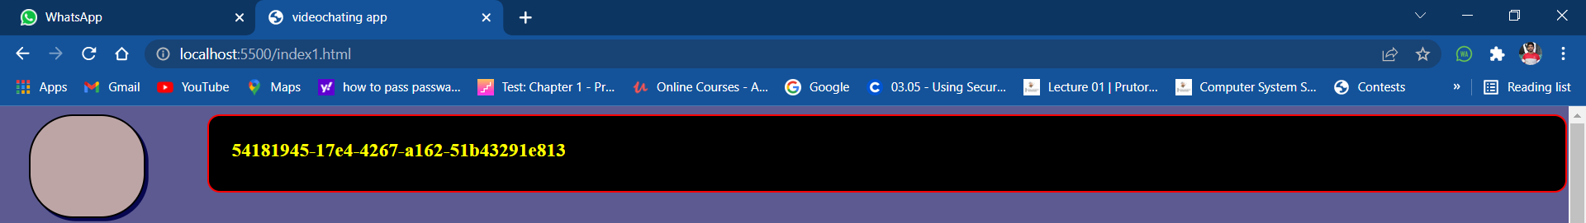

**Footer:-**

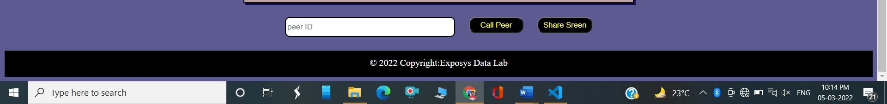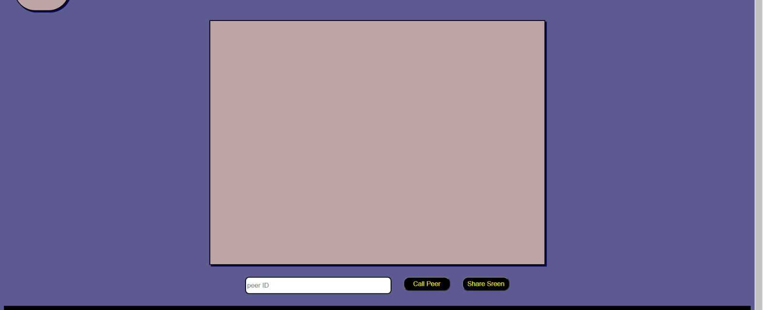

**Client Video Section:-**

**Peer Id Section:-**

